Group Daily Devotions
합심 성경 묵상
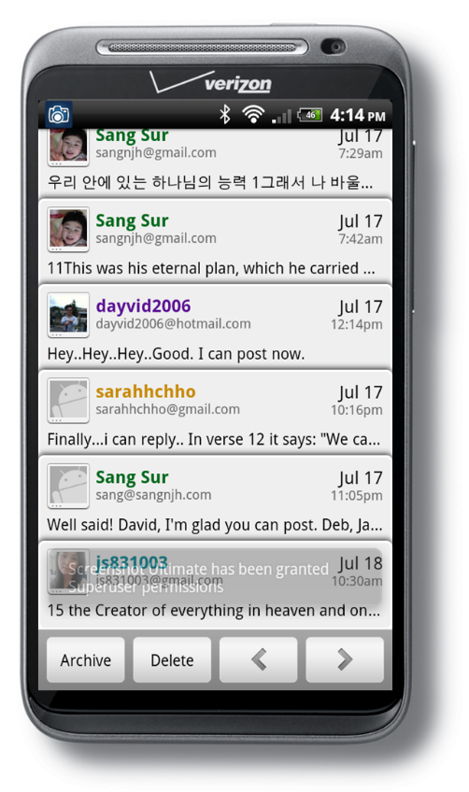
전화기로 함께 말씀을 묵상하고 나눕니다. 한/영.
We meditate on the Word and share on our phones. Korean+English.
Join us. Sign up below or let Sang JDSN know.
서상원 전도사 (sang@sangnjh.com)
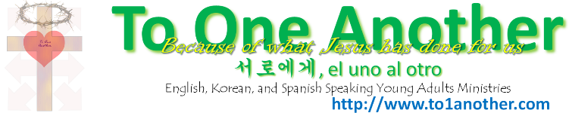

1. Sang | 7. | 13.
2. Sarah | 8. | 14.
3. David S. | 9. | 15.
4. Debora | 10. | 16.
5. Jaesook | 11. | 17.
6. | 12. | 18.

